SIMULACION

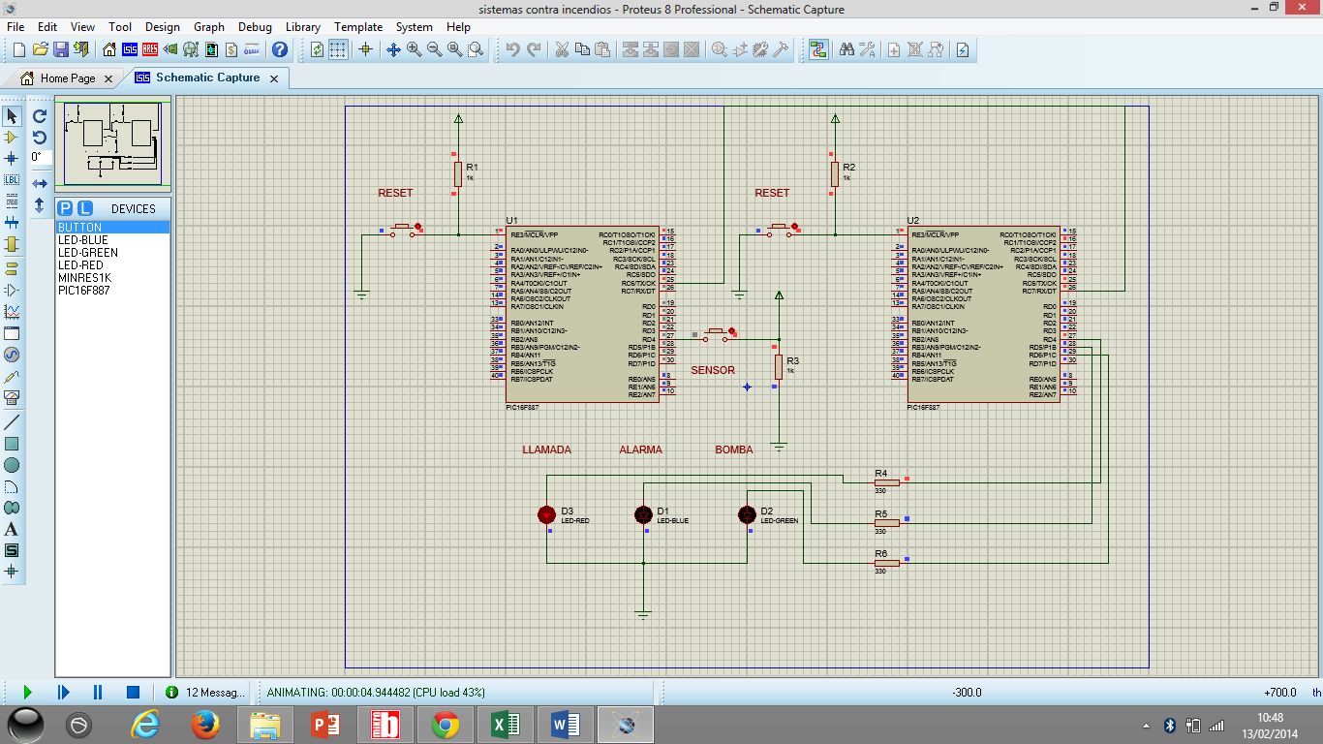

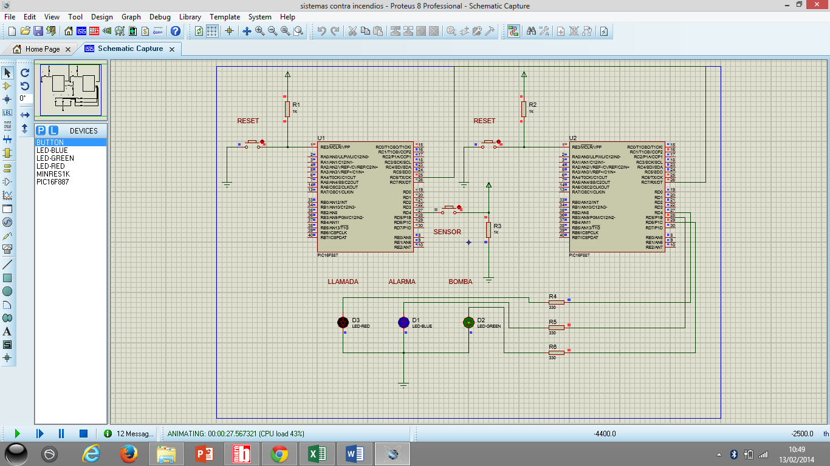

CODIGO PLACA CON SENSOR

program sensor_humo

DIM receive,dato,contador AS BYTE

main:

OSCCON=0X75 'oscilador interno de 4 MHZ

' Registro Oscilador de control

OPTION_REG = 0x06

UART1_Init(9600)

' Registro PUERTO A

TRISA = 0X00

PORTA = 0X00

' Registro PUERTO B

TRISB = 0X00

PORTB = 0X00

' Registro PUERTO C

TRISC = 0X80

PORTC = 0X00

' Registro PUERTO D

PORTD = 0x00

TRISD = 0xFF

' Registro PUERTO E

TRISE = 0X00

PORTE = 0X00

ANSEL = 0X00

ANSELH = 0X00

dato=0

contador=0

while(1)

if (UART1_Data_Ready() = 1) then

receive = UART1_Read()

dato=receive

end if

'reset

if (dato="A") then

PORTB=0X00

dato=0

end if

'sensor

if (PORTD.RD4=1) and (contador=0) then

contador=1

PORTC.RC0 = 1

UART1_Write_text("A")

Delay_1sec

Delay_1sec

Delay_1sec

Delay_1sec

Delay_1sec

Delay_1sec

Delay_1sec

end if

wend

end.

CODIGO PLACA CON RELEE

program Base_alarma

DIM receive,dato,contador AS BYTE

main:

OSCCON=0X75 'oscilador interno de 4 MHZ

' Registro Oscilador de control

OPTION_REG = 0x06

UART1_Init(9600)

' Registro PUERTO A

TRISA = 0X00

PORTA = 0X00

' Registro PUERTO B

TRISB = 0X00

PORTB = 0X00

' Registro PUERTO C

TRISC = 0X80

PORTC = 0X00

' Registro PUERTO D

PORTD = 0x00

TRISD = 0x00

TRISE = 0X00 ' PORTE como salidas digital

PORTE = 0X00

ANSEL = 0X00 ' AN<7:0>

ANSELH = 0X00 ' AN<13:8>

dato=0

contador=0

UART1_Write_text("A")

Delay_1sec

while(1)

if (UART1_Data_Ready() = 1) then

receive = UART1_Read()

dato=receive

end if

if (dato="A") then

PORTC.RC1=1

dato=0

'llamada

PORTD.RD4=1

Delay_ms(800)

PORTD.RD4=0

Delay_ms(800)

PORTD.RD4=1

Delay_ms(800)

PORTD.RD4=0

Delay_ms(1000)

'encender bomba

PORTD.RD5=1

Delay_ms(1000)

Delay_ms(1000)

'encender alarma

PORTD.RD6=1

Delay_ms(1000)

Delay_ms(1000)

end if

wend

end.